# RRO – RRR Online Help Guide – as of 02/01/2017

## Intended Audience

This process guide is intended for Release Agent staff. The Project Teams are advised during the EPMO – Orientation / Kickoff Meeting that the Release Agent staff has assumed this responsibility.

## Rational Terms

References to Rational Collaborative Lifecycle Management components used in this guide:

|  |  |
| --- | --- |
| **Ref** | **Represents…….** |
| RM | Rational Requirements Manager (RM), RDNG, DOORS |
| CCM | Rational Change and Configuration Management (CCM), Rational Team Concert (RTC) |
| QM | Rational Quality Manager (QM), RQM |

## Setting Up Release Agent Work Items

### Prerequisites – Project Team Responsibility

Before a Work Item can be saved in CCM, there are two user defined fields that the Project Team must have first set up in their CCM project / team area: ***timeline****(s)* and ***category****(s).* The Rational Tools Team (RTT) procedure / guidance the Project Teams would follow is presented in procedure ‘How_to_Start_Planning_in_RTC’.

Once a timeline and a category have been established by the Project Team (or the assigned Scrum Master), the Release Agent can then create the necessary Work Items / Tasks for that project. The Release Agent would need to determine which timeline and category to use in the creation of the Work Items / Tasks, should there be multiple values. The ***category*** corresponds to a team; it also corresponds to the ‘**Filed Against**’ field in the Work Item / Task record. The ***timeline*** corresponds to the ‘**Planned For**’ field in the Work Item / Task records you are creating.

Please refer Project Teams to the referenced RTT procedure; **‘How_to_Start_Planning_in_RTC’** for specifics concerning the category(s) and timeline(s) set up**.**

## RRR Prep Procedure Steps

1. Create the Release Readiness record in the teams repository(s) - if this is a multiple product release, RA will need to complete the RRR for each product being released if the products are in different repositories (as they should be). If multiple products in the same repository – can use a single RRR for that release.
2. Enter the data in the top section per the **Field Help Table** below:

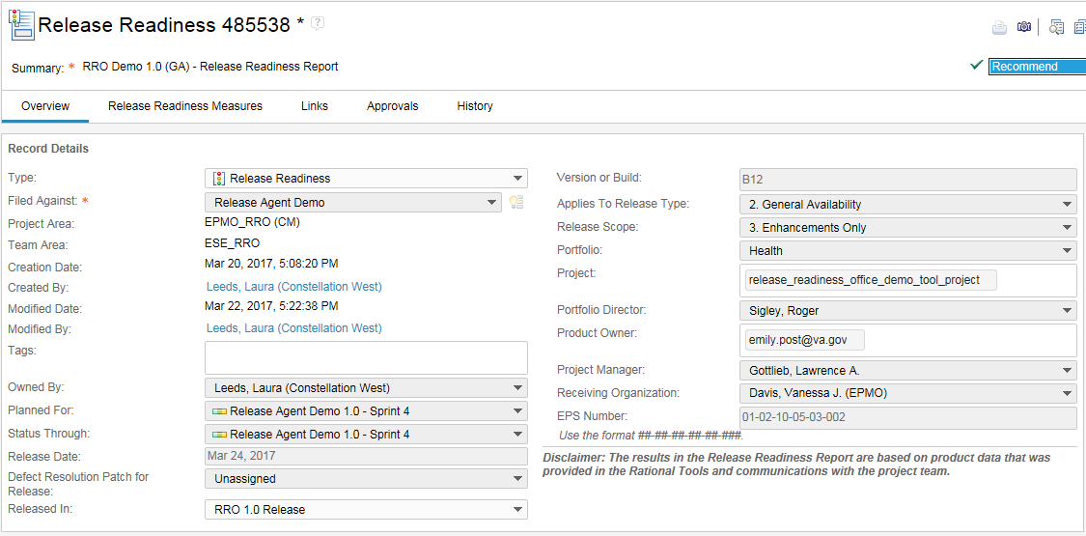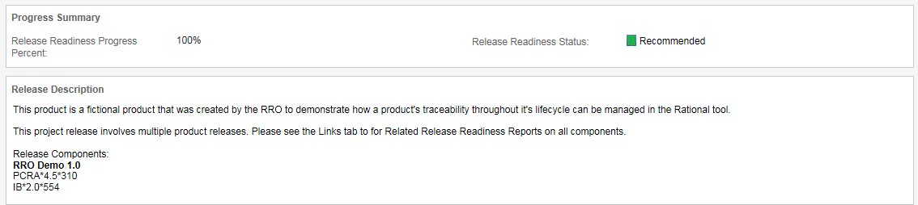

**Field Help Table**

|  |  |
| --- | --- |
| **RRR Field** | **Description on how to complete** |
| ***Summary:*** | Use the RRO Team naming convention:  **Non-VistA**  Product Acronym 0.0.0.0 DEF IOC/GA RRR  E.g.  HDR 13.5.0.0 GA RRR  HDR 13.5.0.1 DEF GA RRR  **VistA**  NameSpace Acronym 0.0 0 DEF IOC/GA RRR  e.g.  MAG 3.0 177 IOC RRR  MAG 3.0 178 DEF GA RRR  **Both**(This is assuming that both are in the same respository)  Product Acronym 0.0.0.0 - NameSpace Acronym 0.0 0 DEF IOC/GA RRR  RSA 12.5.0.0 - SD 5.3 150 GA RRR |
| ***Type:*** | Leave set to the default value: Release Readiness |
| ***Filed Against:*** | Use whatever "Filed Against" category value the team is using for their records in this release |
| ***Project Area:*** | System will fill this with the Repository name |
| ***Team Area:*** | System will fill this based on Filed Against selection. (Team Area associated to the Category) |
| ***Tags:*** | leave blank |
| ***Owned By:*** | RA's name submitting the RRR report goes here |
| ***Planned For:*** | Select the final sprint for this release in the team's timeline list |
| ***Status Through:*** | Select the sprint timeline that corresponds to the current sprint just finished that you are evaluating; or else just the final sprint timeline for this release (so would be the same as the Planned For:" |
| ***Release Date:*** | Select an approximate date of this release to production. This is used in the release metric reporting, so please make sure that the Release Date field is filled in and as accurate as can be. After the RRR is published and you believe that the release should be released, ***verify with the PM as to the actual Release Date and update the RRR***. |
| ***Defect Resolution Patch For Release:*** | Only complete if this is a defect patch - if it is select the release that had these defects (the team needs to define this list in the Release setup menu item Application Admin area) |
| ***Released In:*** | Select the release version applicable to this release (the team needs to define this list in the Release setup menu item Application Admin area) - e.g. PCRA 3*2*45 |
| ***Version or Build:*** | Type in the build number that the team finally ends up on for this Release. E.g B12 |
| ***Released In Change Order:*** | Record the CA SDM change order system record number related to this release, so cross system metrics can be supported |
| ***Applies To Release Type:*** | Select 1 for IOC or Pilot; Select 2 for General Availability |
| ***Release Scope:*** | Select 1 for Defects Only; Select 2 for Defects and Enhancements; Select 3 for Enhancements Only |
| ***Portfolio:*** | Select the correct portfolio: Benefits & Memorials, Corporate, Enterprise Services, Health |
| ***Project:*** | Type in the EPMD Dashboard name of the Project as given from the RA tracking story (from our EPMO RRO) without using spaces but connect with an underscore (_)  e.g. "patient_safety_enhancements_phase_2" |
| ***Portfolio Director:*** | Find and select one of the four (**Health – Sanders, Donald R, BAM - Jay Paluch, Enterprise - Stephen Levy, or Corporate - Eugene Levchenko**) |
| ***Product Owner:*** | Type in the email of the Project Owner "emily.post@va.gov" |
| ***Project Manager:*** | Find and select the Project Manager's name. If not listed leave blank, and enter into the Release Description the PM's name. |
| ***Receiving Organization:*** | Find and select one of the four (**Health - Vanessa Davis, BAM - Ed Pindelski, Corporate - Martin Milbourne, or Enterprise - Tammy Watson**) |
| ***EPS Number:*** | Enter the 13 numbers of the most current EPS (if multiple EPS list the lower number, and note the others in the Release Description).  Enter 00-00-00-00-00-000 if the EPS is not know or is not applicable. |
| ***Release Description:*** | Include a brief description of this release for the product. If multiple products are being released provide a note status this and provide a list of all the Products and Versions being covered. |

1. Create the VIP Release Review work items linked as Children to the Release Readiness record.

If this is a multiple product release also link to those Release Readiness Reports using “Related”.

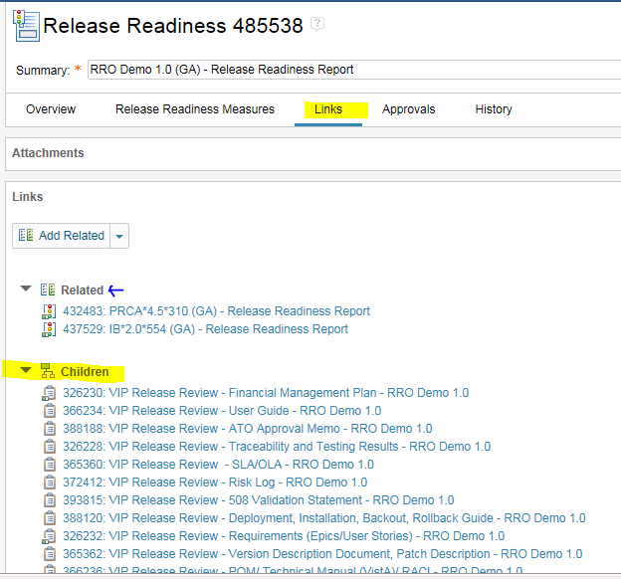

1. Save if you have not saved already. ☺

#### Release Agent Identifies the Category

Using the ‘Manage this Project Area’ option, identify the pertinent **category** for the project which has been set up by the Project Team. Use this value when populating the ‘**Filed Against**’ field in the Work Item / Task records you are creating.

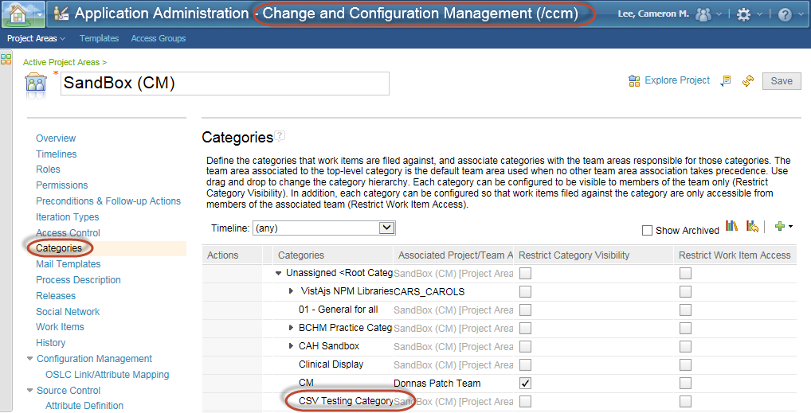

#### Release Agent Identifies the Timeline

Identify the **timeline**(s) for the Release and Sprints, which have been set up by the Project Team. At least one timeline is required in order to save any Work Items.

Using the ‘Manage This Project Area’ option, locate the **Defined Timelines** pertinent to your project. If it does not appear in the drop-down list, need to contact the Project Team. In the interim, if for instance you were looking for a timeline for Sprint 5, and it wasn’t created yet, you could use one of the higher timelines, and then revise it later to use the specific timeline [once it gets created]. For example, in the interim you could assign timeline ‘CSV Test Release 1’, and update it to reflect Sprint

once it is created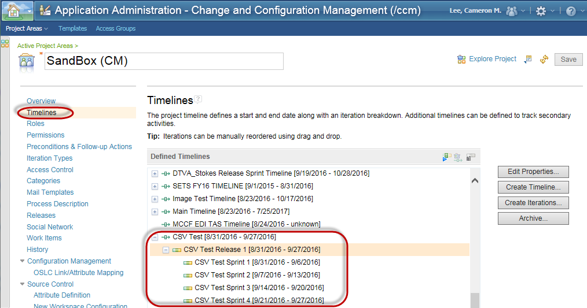

### Create a Review Release Requirement Task – Basic Method

1. Create a Task Work Item in the Project Team’s CCM repository.
2. Populate the same fields you populated for the Story Work Item;

* Be sure to select the timeline associated with the appropriate Sprint number in the **Planned For** field.

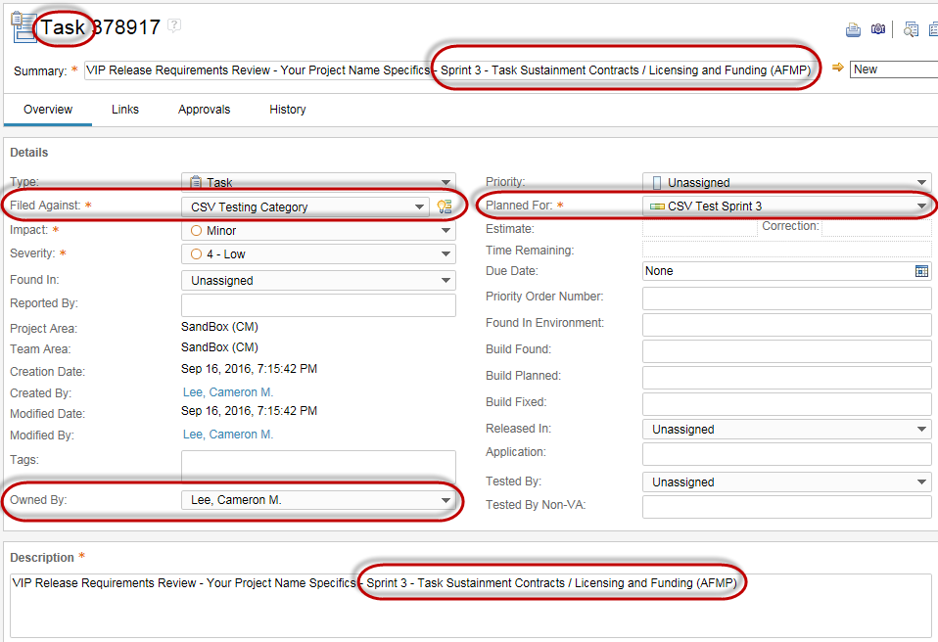

### Faster Way to Create Our Task Work Items – Copy Method

1. From an existing Work Item /Task, click the ‘Create Work Item Copy’ button.

## 

1. The ‘Create Work Item Copy’ window appears. Click the Create Work Item Copy button.

## 

1. When the copy Task appears, update the Summary name and Description accordingly to reflect the particular Work Item Task you are creating. For instance, change ‘Sustainment Contract / Licensing and Funding (AFMP) to ‘SLAs and OLAs ‘.
2. ‘Create Work Item Copy’ window appears. Click the Create Work Item Copy button.

## 

1. After updating the **Summary** and **Description** accordingly, click **Save**.

**NOTE**: If you had established the link to the Epic and Story in the original ‘copied from’ Work Item Task, those links would come with the new copy.

1. Repeat steps 1 – 5 for the remaining Work Item / Tasks.

### Another Way to Create Task Work Items – Using Eclipse

*This method enables you to create the Epic, Story and Tasks in a relatively quick manner. The primary data elements are defined / organized in a Comma Separated Value (CSV) file, which is then imported into the Project Team’s CCM repository. This method requires the* ***Eclipse*** *client executable / application be downloaded and installed onto your laptop.*

## 

## Linking Everything Together

### Link the Review Release Requirement Tasks Together

**NOTE:** The intent behind the following screen prints is strictly to show the procedure for [a] linking the Work Item Tasks to the Work Item Story; and then [b] linking the Work Item Story to the Work Item Epic. The specific ‘Summary’ name and ‘Description’ values shown are for ***illustrative purposes only***.

1. Go to the **Links** tab on each Task.
2. In the **Links** sub-section, select *Set Parent*from the **Add Related** drop-down-list-box., then click on Set Parent

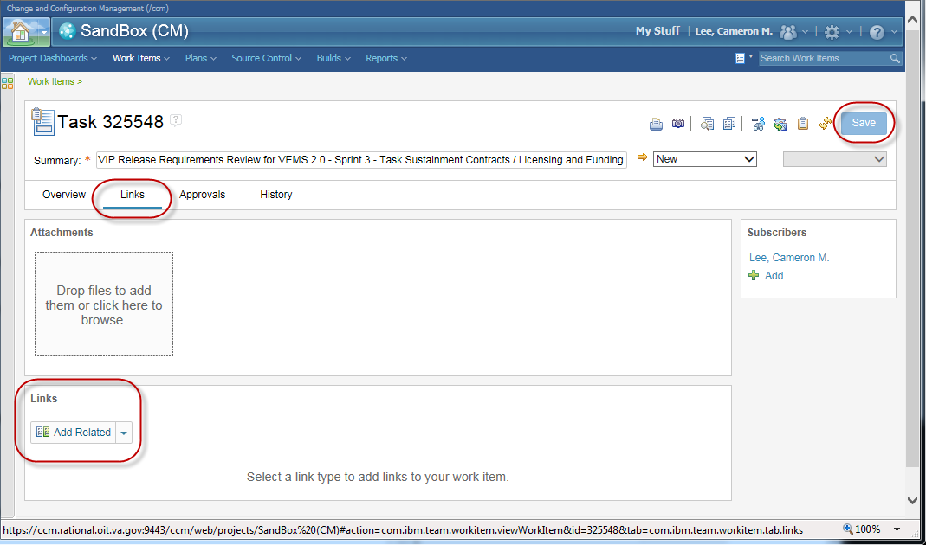

1. Select the Story Work Item created earlier and click **OK**
2. Click **Save.**

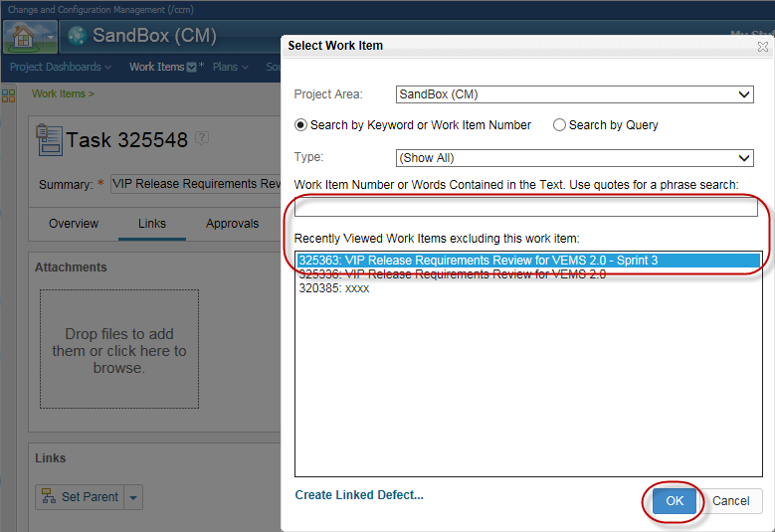

### Link the Work Item Task to the Corresponding Release Compliance User Story - - Setting the ‘Implements Requirement’

**NOTE:** The intent behind the following screen prints is strictly to show the procedure for linking the Work Item Task to the Release Compliance User Story. The specific ‘Summary’ name and ‘Description’ values shown are for ***illustrative purposes only***.

**http://icons.iconarchive.com/icons/oxygen-icons.org/oxygen/32/Status-dialog-information-icon.png**

While you have the Work Item Task in front of you, there is an additional link that should be established as well, and supports our goals of establishing Traceability within our project efforts.

1. **BEFORE** starting this step, confirm that the Project Team has already copied / cloned the Release Compliance User Stories into their RM repository. If those user stories have not been set up, the ‘Implements Requirement’ link can be established at a later date, therefore skip this step and resume at step ‘**1.4.3. Link the Review Release Requirement Story to the Epic**’ below.
2. Otherwise, go to the **Links** tab on each Task.
3. In the **Links** sub-section, select *Implements Requirement*from the **Add Related** drop-down-list-box.

## 

Select ‘**Link to existing: Requirement**’ radio button.

Click **OK.**

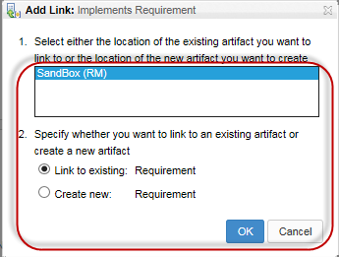

In the Requirement Selection window, locate the project’s Requirements folder in the **Filter Display by Folder** scroll down.

Click on the corresponding Release Compliance User Story, and click **OK**.

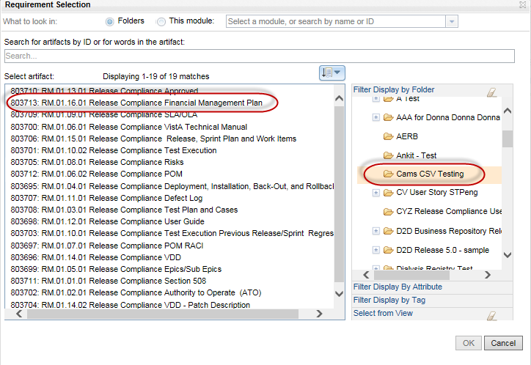

**Implements Requirement** link has been established.

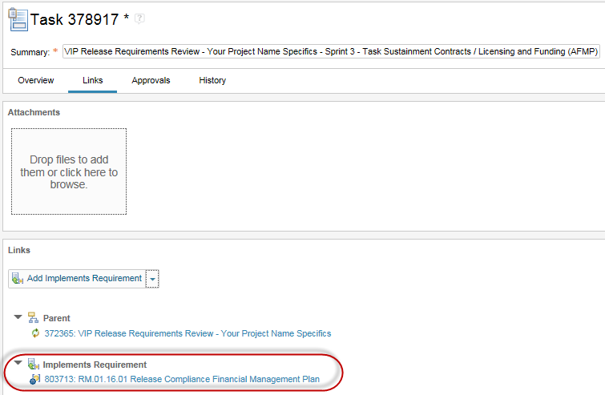

Again, follow these same steps for the remaining Work Item Tasks while you have them in front of you. Just saves time.

### Link the Review Release Requirement Story to the Epic

1. Go to the **Links** tab on the Story.
2. In the **Links** sub-section, select *Set Parent*from the **Add Related** drop-down-list-box., then click on Set Parent

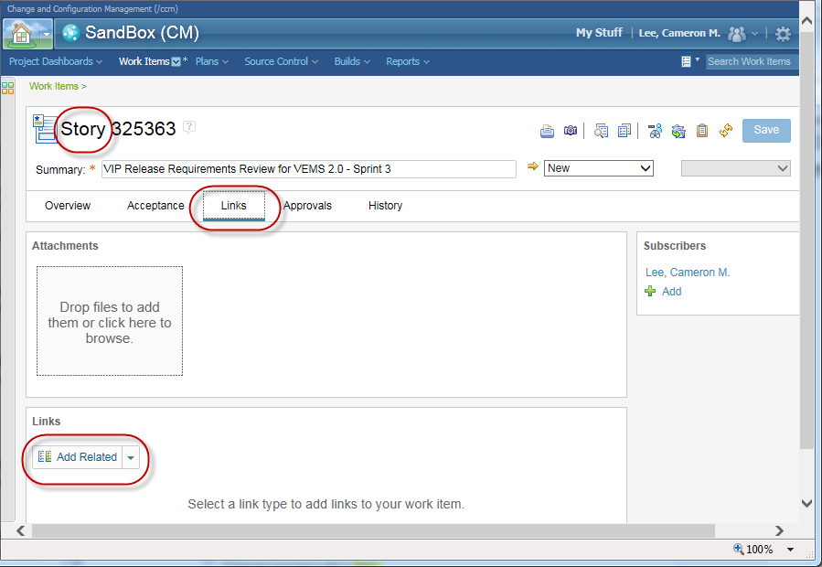

1. Select the Epic Work Item created earlier and click **OK.**
2. Click **Save.**

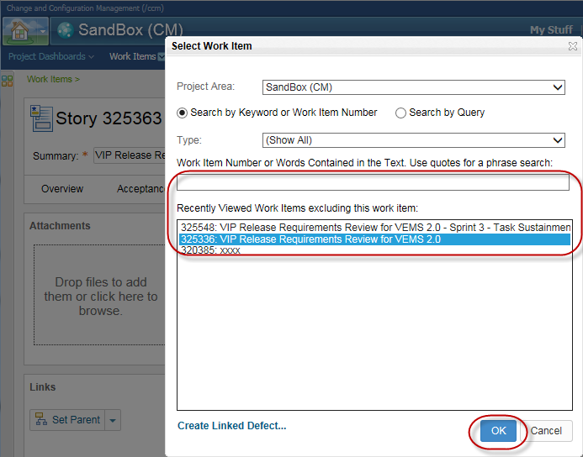

**Set up of the VIP Release Requirements Review Work Items is complete!**

## 

## Updating the Report Metrics

1. Update the record to record the results of your Work Item Reviews on the Release Readiness Measures tab.
   1. Note: All VistA releases must show evidence of passing a VistA SQA Checklist test as part of evidence of Measure 5 for Regression Testing.
2. Before finalizing the RRR, check the Links tab for a ‘Related’ link to an Elective ETS Services task.

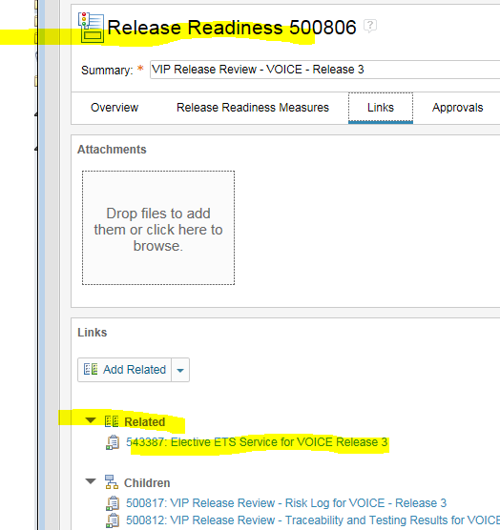

If a link exists open it and copy the statement in the Description field prefaced by the phrase “Elective ETS Services: ….” and paste into the comment of measure ‘#4 User Stories Passed’. If there is no link, do nothing.

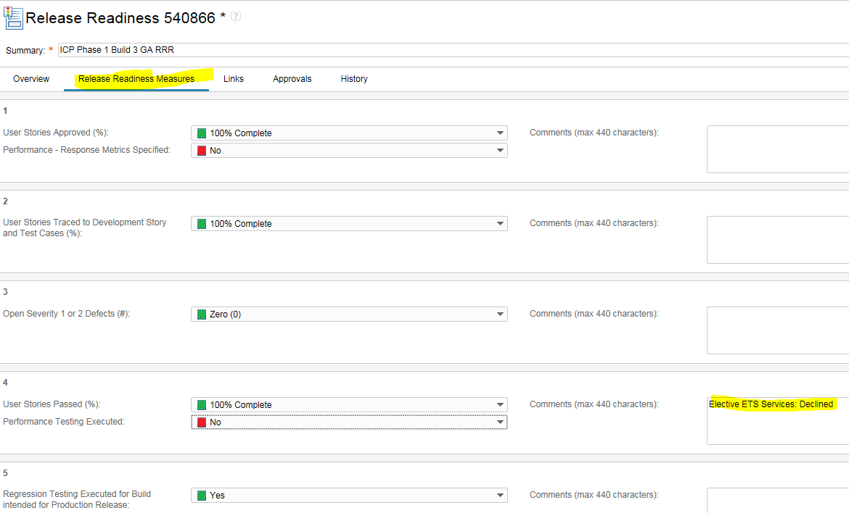

1. Update Release Readiness record Status Field:

* Set the Status In Progress – until your review is complete
* Set the Status to Recommend or Not Recommend – when your review is complete
  + *If Not Recommended – and the team goes back to fix things – just roll the RR status back to In Progress, and change the approval to Recommend when/if they get it.*
* Use Defer when no Recommendation is going to be given
* Use Invalidate when the RRR record needs to be abandoned

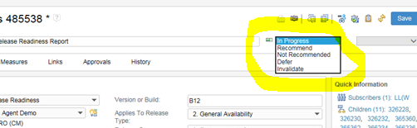

1. Submit for RRO Peer Review and get ready to record CD2 results:

* For **RRO_Peer_Review** – add the “Review” type - assign to Bill Atwater or his back-up. Bill or whomever you assign will get an email from Jazz.
* For **CD2_Approval** – add the “Approval” type – (note that the RA will be named as the approver until one day when perhaps the VIP Triad might be able to use the tool. In the meantime the RA will just record the outcome of the CD2 meeting here – changing the State from Pending to “Approved” or “Rejected”.)
* If a CD 2 is rejected, then later approved.
  + On RRR Approvals tab, create an Approval Item titled “CD2_Approval”.  Set the approver to the RA.  Save with status of Pending.
  + After rejected CD 2.  Change the status of the Approval item created in step 1 to Rejected.  Save the RRR.
  + After subsequent approval of release, Change the status of the same approval item created in Step 1 to Approved.  Save the RRR.

**For Tracey to get the record of the rejected and then approved in the metrics, to be in history, there needs to be a Save action between the Rejected and Approved Statuses.**

**If you do it all in 1 action, the Rejection will not be recorded.  Also, there should only be 1 “CD2_Approval” item.**

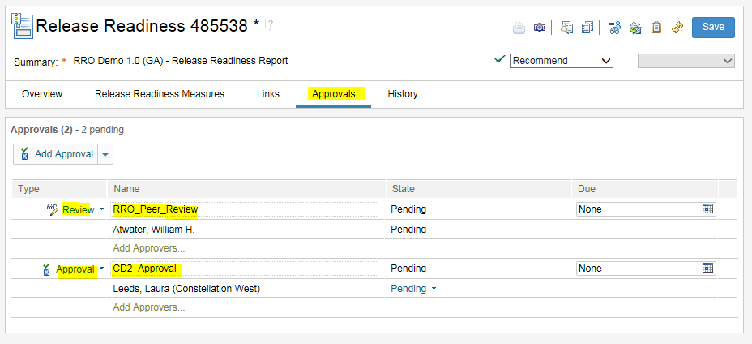

## Creating the RRR Announcement

* 1. After receiving RRO Peer Review approval, and making sure all Work Item children are in the DONE status….
  2. From within the RRR record Select the Print icon on the record

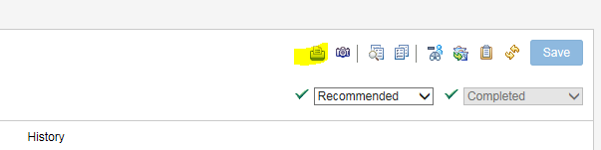

* 1. (Close the “Print” pop-up) Then select the browser File – Edit with Microsoft Word menu item

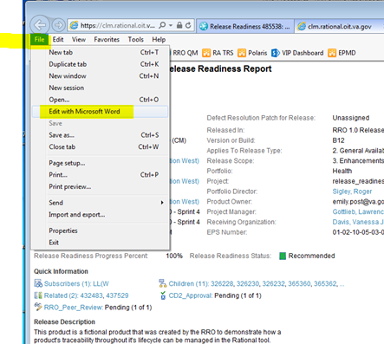

1. Save as a PDF with the naming convention of:

“Product Version (GA/IOC) – Release Readiness Report ID#”

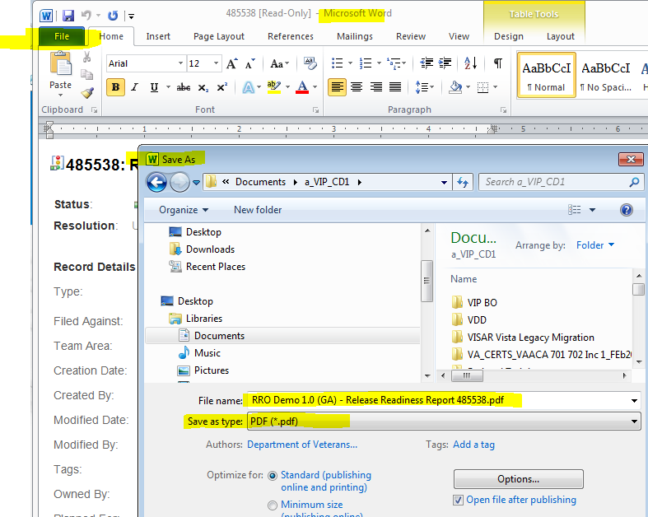

1. Upload the .pdf file to our TRS SharePoint site for our RRO Release Readiness Reports: <https://vaww.vaco.portal.va.gov/sites/OIT/epmo/TRS/RRO%20%20Release%20Readiness%20Reports/Forms/AllItems.aspx>
2. Send the Release Readiness Report announcement email:
   * + Address to the [RA Kickoff Mtg Invitee List and RRR Recipient List](https://vaww.vaco.portal.va.gov/sites/OIT/epmo/TRS/RRO%20%20Release%20Agent%20Internal%20Process/Templates/Release%20Agent%20Orientation-Kickoff%20Mtg%20Invitee%20List%20and%20RRR%20Recipient%20List.docx)
     + Provide a link to the Release Readiness Report (copy the URL) in Rational (in the main link of the email)
     + Also provide a link to the PDF file on our Sharepoint, indicating it can be used for those without Rational access.

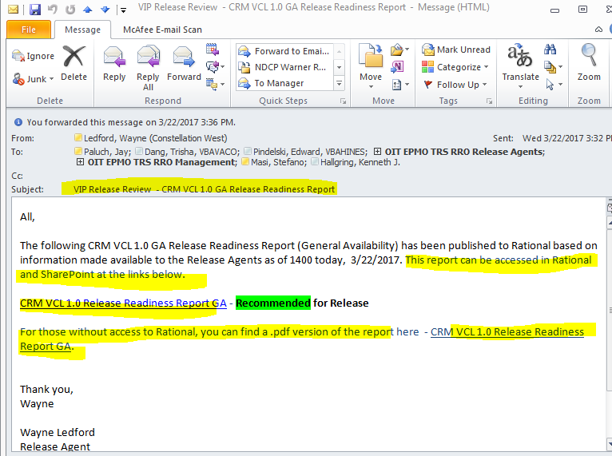

1. After the CD2 meeting – update the CD2 Approval on your Approval tab on the Release Readiness record - (RA sets it themselves) Approved = Approved; Rejected – CD2 did not approve.
   * + If a CD 2 is rejected, then later approved.
       1. On RRR Approvals tab, create an Approval Item titled “CD2_Approval”.  Set the approver to the RA.  Save with status of Pending.
       2. After rejected CD 2.  Change the status of the Approval item created in step 1 to Rejected.  Save the RRR.
       3. After subsequent approval of release, Change the status of the same approval item created in Step 1 to Approved.  Save the RRR.

**For Tracey to get the record of the rejected, then approved in the metrics, to be in history, there needs to be a Save action between the Rejected and Approved Statuses.**

**If you do it all in 1 action, the Rejection will not be recorded.  Also, there should only be 1 “CD2_Approval” item.**

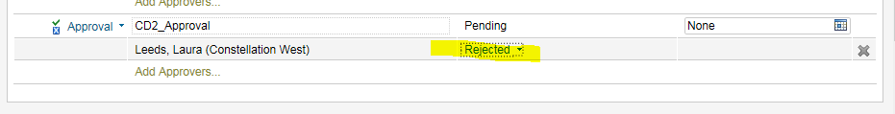

## Appendix

### RRR – Release Readiness Progress Percent - Calculation Rules

**Sum of the points assigned for each applicable measure, divided by, the total maximum number of points allowed for each applicable measure.**

1. User Stories Approved (%):

* Unassigned gets 0 points
* 0-20% Complete gets 1 point
* 21-40% Complete gets 2 points
* 41-60% Complete gets 3 points
* 61-80% Complete gets 4 points
* 81-99% Complete gets 5 points
* 100% Complete gets 6 points
* NA gets 6 points

Performance – Response Metrics Specified: (zero points regardless)

1. User Stories Traced to Development Story and Test Cases (%):

* Unassigned gets 0 points
* 0-20% Complete gets 1 point
* 21-40% Complete gets 2 points
* 41-60% Complete gets 3 points
* 61-80% Complete gets 4 points
* 81-99% Complete gets 5 points
* 100% Complete gets 6 points
* NA gets 6 points

1. Open Severity 1 or 2 Defects (#):

* 0 gets 5 points
* otherwise 0 points

1. User Stories Passed (%):

* Unassigned gets 0 points
* 0-20% Complete gets 6 point
* 21-40% Complete gets 6 points
* 41-60% Complete gets 6 points
* 61-80% Complete gets 6 points
* 81-99% Complete gets 6 points
* 100% Complete gets 6 points

Performance Testing Executed: (zero points regardless)

7. Unmitigated Open Risks with High (Red) Exposure Level:

* 0 gets 5 points
* NA gets 5 points
* otherwise 0 points

All the following 12 measures receiving this pointing:

* Yes gets 6 points
* NA gets 6 points
* otherwise 0 points

5. Regression Testing Executed for Build intended for Production Release:

6. IOC Exit Site Concurrence:

8. Section 508 Office Release Recommended:

9. ATO Approved and Valid:

10. Version Description Document (VDD) Complete through Current Product Release Component Builds:

11. Deployment and Installation Procedures Complete through Current Product Release Component Builds:

12. Back Out or Rollback Procedures Complete through Current Product Release Component Builds:

13. Production Operations Manual (POM) or Technical Manual (VistA) Complete:

14. Production RACI Chart Complete:

15. SLAs and - or OLAs Approved:

16. Acquisition and Financial Management Plan Approved:

17. User Documentation Complete: